- PSEUDOCODE:INFIX TO POSTFIX

BEGIN
FUNCTION precedence(op)
IF op = '+' OR op = '-' RETURN 1
IF op = '*' OR op = '/' RETURN 2
IF op = '^' RETURN 3
RETURN 0
END FUNCTION
FUNCTION infixToPostfix(expression)
CREATE empty stack S
CREATE empty string postfix
FOR each character ch in expression DO
IF ch is operand THEN
postfix ← postfix + ch
ELSE IF ch = '(' THEN
PUSH ch into S
ELSE IF ch = ')' THEN
WHILE top of S ≠ '(' DO
postfix ← postfix + POP(S)
END WHILE
POP(S) // remove '(' ELSE // operator
WHILE S not empty AND precedence(top(S)) ≥ precedence(ch) DO
postfix ← postfix + POP(S)
END WHILE
PUSH ch into S
END FOR
WHILE S not empty DO
postfix ← postfix + POP(S)
END WHILE
RETURN postfix
END FUNCTION
END

- PSEUDOCODE:INFIX TO PREFIX

BEGIN
FUNCTION reverse(expression)
RETURN reversed expression
END FUNCTION
FUNCTION infixToPrefix(expression)
// Step 1: Reverse expression
expression ← reverse(expression)
// Step 2: Swap brackets
FOR each character ch in expression DO
IF ch = '(' THEN replace with ')' ELSE IF ch = ')' THEN replace with '(' END FOR
// Step 3: Convert to postfix
postfix ← infixToPostfix(expression)
// Step 4: Reverse result
prefix ← reverse(postfix)
RETURN prefix
END FUNCTION
END

INFIX TO POSTFIX WORKFLOW

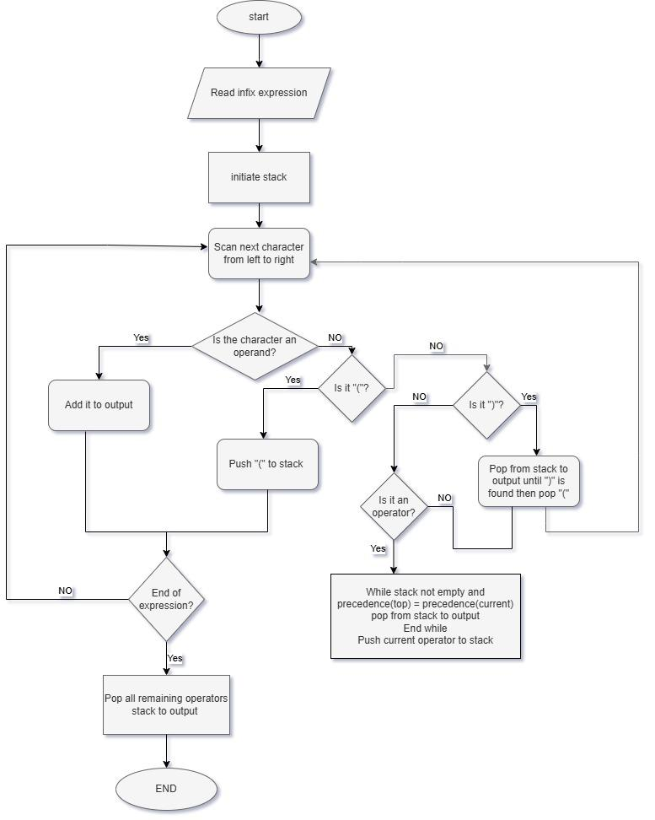

INFIX TO PREFIX WORKFLOW

